Practical -7

Module Name: Product Quantity / Cart Quantity
Website URL: https://demo.nopcommerce.com/

TC01 – Verify Minimum Valid Quantity
Steps:
- open nopCommerce website.
- Select any product.
- Add the selected product to the cart.
- Set the quantity to 1.
- Update the shopping cart.
- Check the result.
screenshot: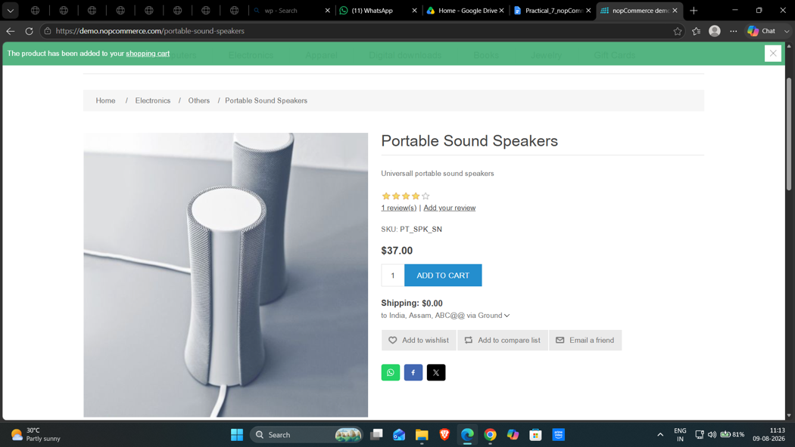
Test Input: 1
Actual Result: Quantity 1 was accepted, and the product was added to the shopping cart.
Status: Pass

TC02 – Verify Quantity Below Minimum
Steps:
- Open the nopCommerce demo store.
- Choose a product from the available items.
- Place the product in the shopping cart.
- Enter 0 in the quantity field.
- Click Update Shopping Cart.
- Observe the validation message.
screenshot: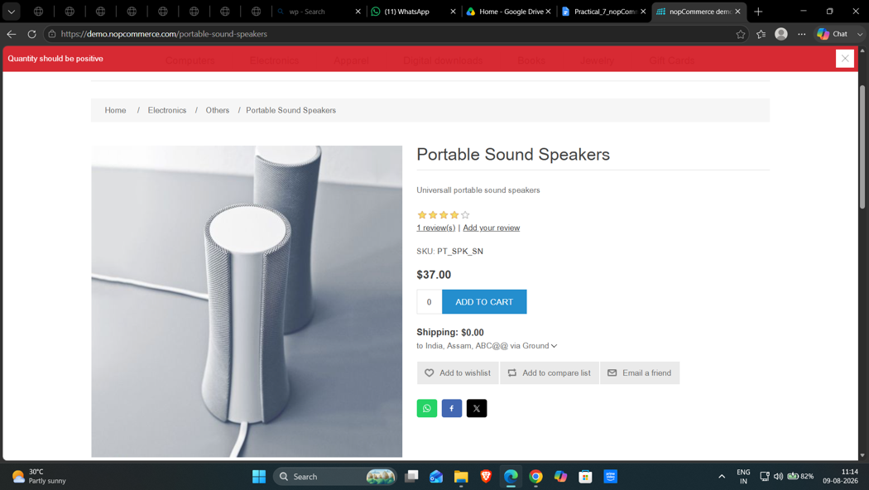
Test Input: 0
Actual Result: The system displayed a quantity validation message and did not accept quantity 0.
Status: Pass

TC03 – Verify Quantity Above Minimum
Steps:
- Visit the nopCommerce website.
- Open a product details page.
- Add the product to the cart.
- Enter 2 as the quantity.
- Apply the cart update.
- Verify the displayed quantity.
screenshot: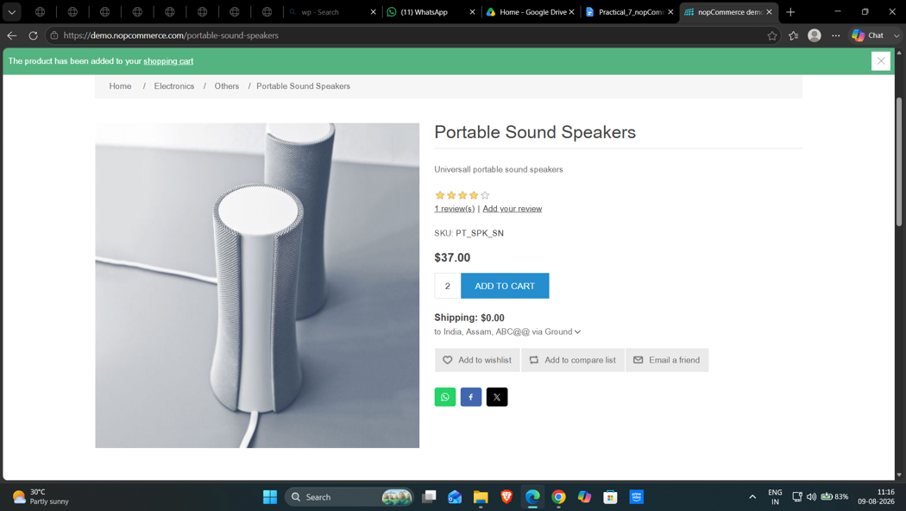
Test Input: 2
Actual Result: Quantity 2 was accepted, and the product was added to the shopping cart.
Status: Pass

TC04 – Verify Quantity with Leading Zero
Steps:
- Navigate to the demo shopping website.
- Select a product and add it to the cart.
- Open the shopping cart page.
- Type 01 in the quantity field.
- Update the cart.
- Check the system response.
screenshot: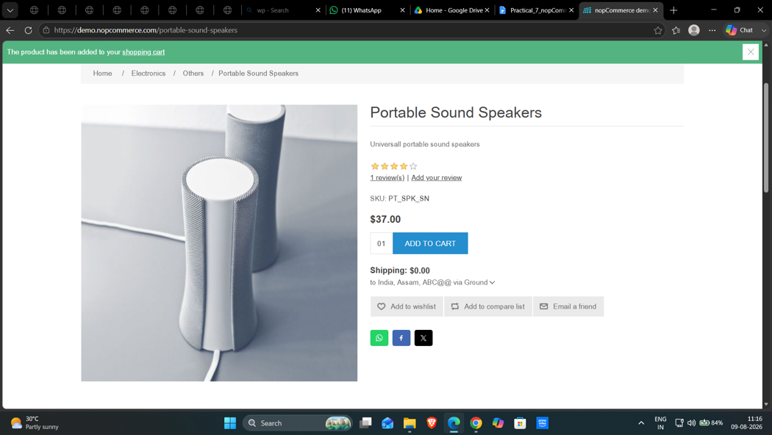
Test Input: 01
Actual Result: The leading-zero quantity was accepted and processed as a valid quantity.
Status: Pass

TC05 – Verify Quantity Near Maximum Limit
Steps:
- Open the nopCommerce demo store.
- Select a product from the store.
- Add the product to the shopping cart.
- Enter 9999 in the quantity box.
- Update the cart details.
- Observe the result.
screenshot: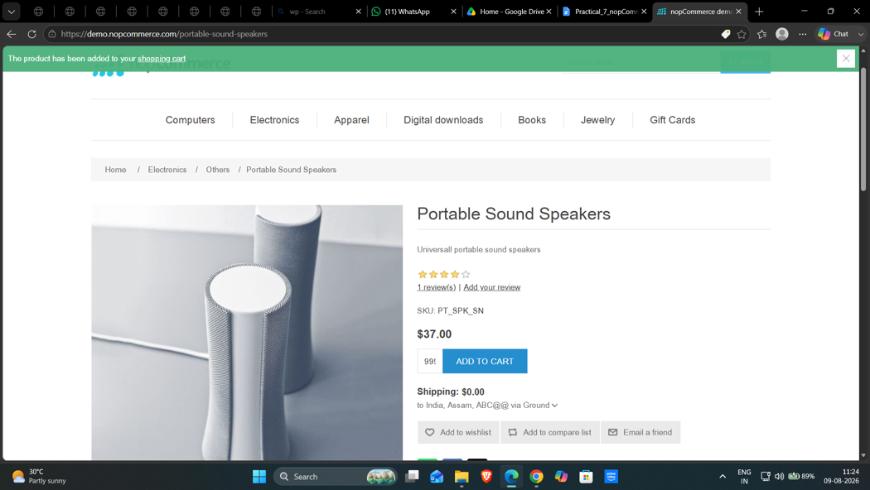
Test Input: 9999
Actual Result: Quantity 9999 was accepted as a valid quantity.
Status: Pass

TC06 – Verify Maximum Quantity
Steps:
- Access the nopCommerce website.
- Choose a product from the product list.
- Add the item to your cart.
- Set the quantity to 10000
- Click Update Shopping Cart.
- Check the result.
screenshot:
Test Input: 10000
Actual Result: Quantity 10000 was accepted by the system.
Status: Pass

TC07 – Verify Quantity Above Maximum
Steps:
- Open the nopCommerce demo website.
- Select a product and add it to the cart.
- Go to the Shopping Cart page.
- Enter 10001 in the quantity field.
- Select Update Shopping Cart.
- Check the validation response.
screenshot: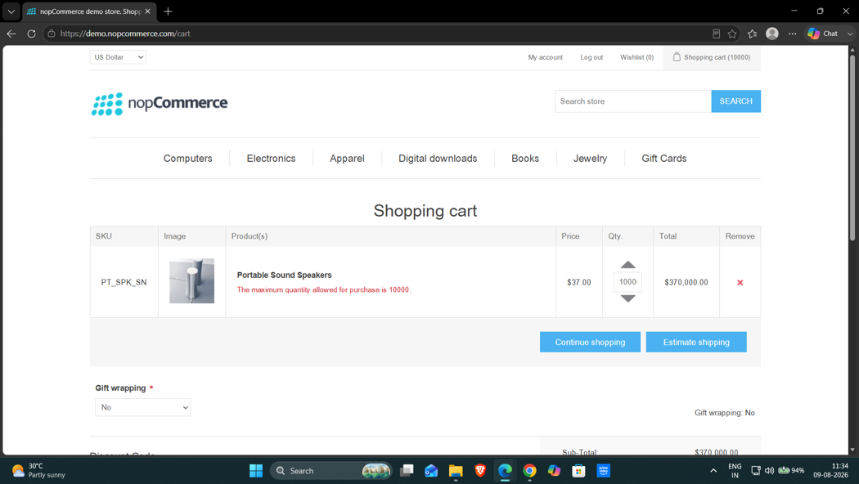
Test Input: 10001
Actual Result: The system rejected 10001 and displayed a message indicating that the maximum quantity allowed is 10000.
Status: Pass

TC08 – Verify Negative Quantity
Steps:
- Launch the nopCommerce demo store.
- Add a product to the cart.
- Open the shopping cart.
- Enter -1 as the quantity.
- Try to update the cart.
- Observe the result.
screenshot: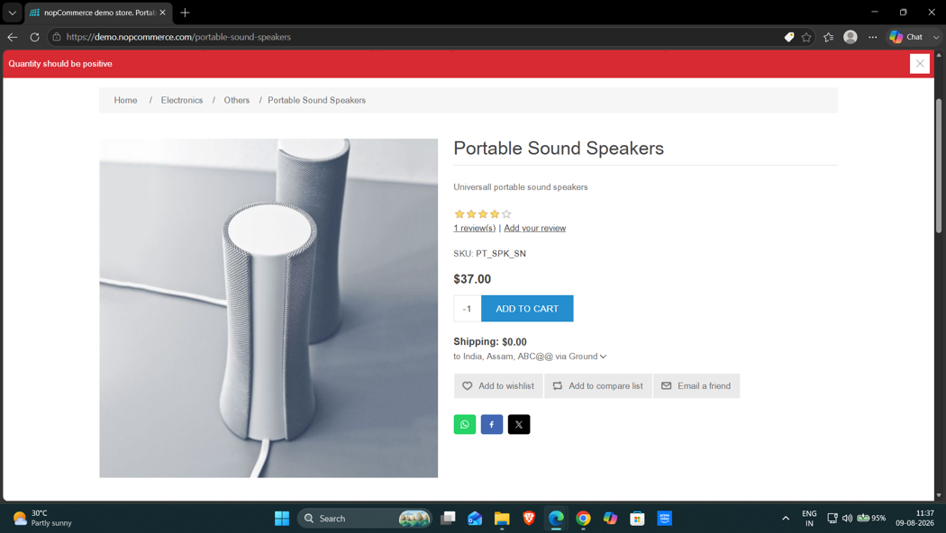
Test Input: -1
Actual Result: The system displayed “Quantity should be positive” and did not accept the negative quantity.
Status: Pass

TC09 – Verify Negative Decimal Quantity
Steps:
- Visit the nopCommerce website.
- Select a product and add it to the cart.
- Open the shopping cart page.
- Enter -1.5 in the quantity field.
- Update the cart.
- Check the displayed message.
screenshot: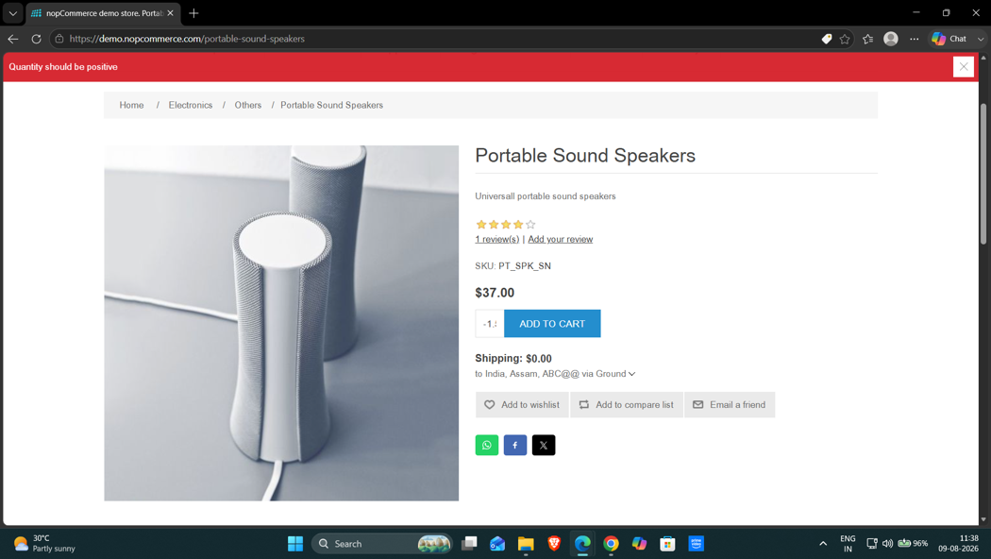
Test Input:-1.5
Actual Result: The system displayed “Quantity should be positive” and did not accept the negative decimal quantity.
Status: Pass

TC10 – Verify Positive Decimal Quantity
Steps:
- Open the nopCommerce demo store.
- Choose a product and add it to the cart.
- Navigate to the shopping cart.
- Enter 1.5 in the quantity field.
- Apply the cart update.
- Observe the system response.
screenshot: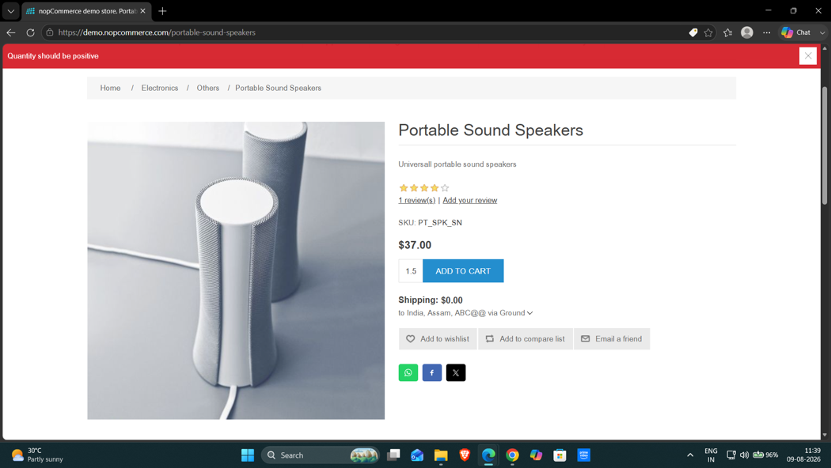
Test Input: 1.5
Actual Result: The system displayed “Quantity should be positive” and did not accept the decimal quantity.
Status: Pass

Conclusion and Recommendations
Conclusion: Boundary Value Analysis was performed on the Product Quantity and Shopping Cart module. Different quantity values were tested to check the system's response to valid and invalid inputs.
Issues Found: No functional issues were recorded in the original test report.
Recommendations:
- Validate minimum and maximum quantity limits.
- Display suitable messages for invalid quantity values.
- Reject unsupported negative and decimal quantities.
- Ensure that cart quantities are updated correctly.

